NRES 598: Human Dimensions of the Neighborhood Environ, Fall 2016  
**Neighborhood Civic Life Tool**.

# **Statistical Data**. Begin with some online resources. We will use them to estimate some of the statistical data for our neighborhoods. If we were doing this under contract, for publication, for a thesis, etc., data from other sources such as the census, GIS data, police reports, etc., would be used thanks to their greater validity and reliability. The collection of the ideal data, however, is both costly and time consuming and expensive, and some online sources will give us close estimates of the ideal data.

## House price, crime, and demographic data.

### Use trulia.com

#### Everyone should use the same source so that the data are comparable across all of the neighborhoods we use.

#### In trulia.com:

##### Type in the address of a house in the neighborhood.

**4654 Timber View Dr**

**Waterloo, IL 62298**

##### Record the estimated value (or price, if for sale).

##### **$305,000**

##### Scroll to the Property Details section and note the average list price for similar homes for sale in this neighborhood and in this zip code.

**In this neighborhood - none listed, however, average assessed value per St Clair County Parcel and Real Estate Tax Inquiry is $267,700**

**In this zipcode $214,949**

##### Scroll to “See businesses, schools, and crimes near this home” section.

###### Record the number of major crimes (violent, non-violent crimes) near the home in 2016. (Sometimes more than one year’s data is shown; we need only 2016.) If listed, omit traffic citations from the crime tally.

**No crimes listed. Interviewed neighbor who moved into the neighborhood in 1998, he stated he is not aware of any crimes ever within the neighborhood**

###### Record the median age, percent married, percent college graduates for the area.

**Median age: 43**

**Percent Married: 75%**

**Percent College Graduates: 43**

###### Record the schools (and their quality) and distance to schools.

###### **Rogers and Zahnow Elementary 4.65 mi. score:8**

###### **Waterloo Junior High 4.83 mi. score:9**

**Waterloo High 6.74 mi. score:8**

#### Repeat, if necessary, so that all parts of the neighborhood are included. You can tell this from the map that trulia.com displays.

### Use walkscore.com

#### For each house or apartment included above, type the same address into walkscore and record the resulting walkscore and transit score.

**Walkscore: 2**

**Transit Score: Not available**

### Population Density.

#### Divide the city population by the city’s area in square miles. This data can be found in most city web sites. If not, use the census. Record results (population, area, density) as well as noting the source (city, census, etc.).

#### **7.66 square miles; 10,140 population = 1,324 people/square mile**

## Average length of residence (turnover rate). How often do people leave the neighborhood?

### Realtors tend to know this. One simple way is to call a realtor and ask.

### Alternatively, find the number of residences in a neighborhood and lookup the number of home sales in the neighborhood that month (usually published in the newspaper, but also available on realtor.com, trulia.com, etc.) Add up the sales over the year, then divide by the number of homes.

#### The annual houses sold/total homes ratio is the turnover rate.

#### Average length of residence can be estimated by 1/turnover (where annual turnover rate is given as a probability) or 100/turnover (when turnover is expressed as a percentage).

#### **The first lot in the neighborhood was sold in 1997, the last lot was sold in 2014. Since 1997, 2 homes have been sold (1 was a foreclosure). The remaining 9 homes are still occupied by the original owner.**

# **Political Activity Measures**

## Using a map or google maps, determine (and record) all street names in your neighborhood. If large streets/boulevards that cross into multiple neighborhoods, find the address range restricted to your neighborhood bounds (ex. 1000 block of Xyz Blvd.)

**Homes are only located on Timber View Dr**

## Using the city web site (in most cases) or public library resources, Look up home addresses of the members of city boards for your city.

### These include (but are not limited to) boards such as library, parks, public safety, public arts, citizen review boards, etc. for your city.

### Include precinct captains, which may come from party web sites or county clerk website.

### Cross reference board member home addresses with your street name data to see if they are within the bounds of your neighborhood

### Record the number board members and names of the boards for all who live within your neighborhood.

**Following review of all resources listed, no board members were found in the neighborhood.**

## Find out if your neighborhood has an Elks, Moose, or Eagle Lodge within or near it.

**None**

## Find out if your neighborhood as a Home Owners Association or a Neighborhood Association.

**There are neighborhood by-laws. One neighbor is considered “president of the association”, however, no meetings have been held since the late 90’s.**

### Look up reports, or call a HOA board member. Ask about attendance at last two meetings (since membership of most HOA’s is mandatory).

### Neighborhood Associations are usually voluntary membership organizations. Look up (usually online, but possibly in a mailing) or call a board member to find out how many homeowners belong. Convert this to a percentage of homes using the home total collected in part I of this data collection effort.

## Drive or walk through the streets of your neighborhood.

### Record number of homes with yard signs for candidates and political or social causes (examples include “My house pays Carle’s Property Tax” signs, “We Support the Community Broadband” signs, etc.,). Record the number of homes with “little libraries” and “little pantries” in their front yards.

**There is one yard with a political sign; however, the farmer that owns the land at the entrance to the neighborhood has many political signs located along the entrance (see photos below). Also, interesting to note, this is a rural area and all signs in our area are republican – as discussed in class.**

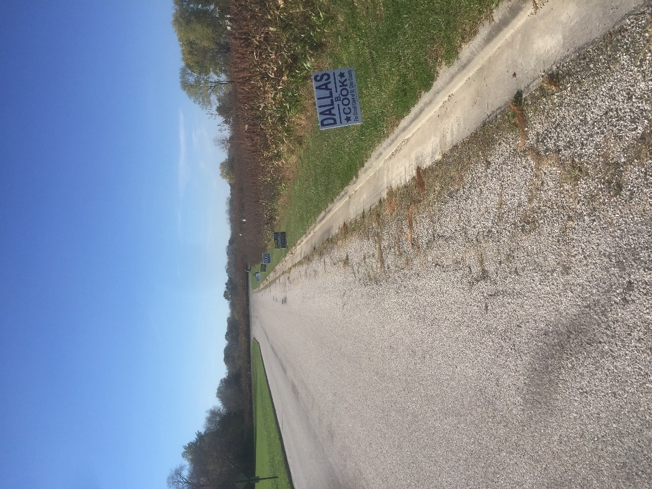

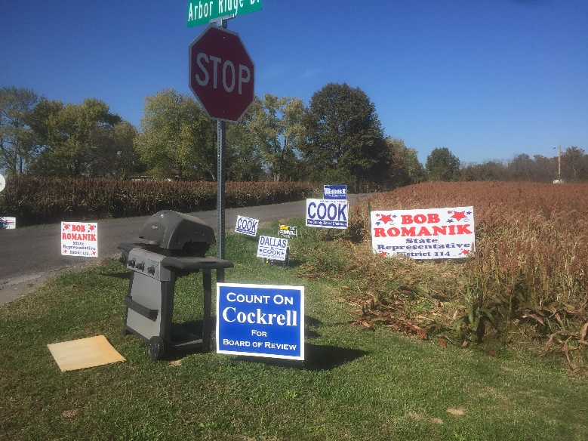

(ironically, a neighbor was leaving their “free grill” out for the taking on the day I snapped this photo)

### Report the numbers of homes for each of the above; convert this to a percentage of homes and report percentage as well.

1 home – 9%

# **Non-Political Engagement**.

## Drive or walk through the streets of your neighborhood. (You are doing this already for part II; don’t make more work than needed: obviously you can record this on the walkthrough noted above!)

### Using a checklist, record the numbers of the following within the neighborhood and within a ten minute walk of the neighborhood. Keep lists separate (for within neighborhood and within a ten minute walk.

_______ Schools

_______ Restaurants (including coffee shops)

_______ Parks

_______ Libraries

_______ Open Markets (Farmer’s Markets, etc.)

_______ Retail Stores

___1____ Community service organizations (ex: neighborhood watch, gardeners’ club, etc.)

_______ Community sports organizations (community softball league, etc.)

___3____ Availability of local newspaper subscriptions (record number available)

_______ Churches / religious centers

_______ Community centers

_______ Theatres

_______ Walking/trails trails

## Drive or walk through the streets of your neighborhood. For this, evening (dusk) or slightly after dark is best. May be combined with the above, but actually this is usually easier if done on a separate walkthrough or drive-through.

### Record the numbers of homes with outside holiday decorations and no decorations on each street.

### **4 homes with decor – 7 without**

### Report by street, and for neighborhood as a whole.

#### It is not uncommon to find streets with no decorations and streets with many decorations in the same neighborhood.

#### This is worth collecting at the street or block level; we may or may not us it at this level, but collecting it at that level now is better and easier because aggregating up is simpler than going back to collect the low level of aggregation data.