Neighborhood health assessment tool: How conducive is your neighborhood to good health?

**Proximity to pollution sources (industry, road congestion)**

-count cpm’s (cars per minute!) on the busiest street and slowest street. Do this at 5:30 pm (up for debate). Count cars going by for 1 minute, then wait a minute and do it again. Do this three times and then take the average.

Busy Street:

____**2**_____ cpm’s

_____**1**____ cpm’s

____**0_**____ cpm’s

____**1**_____ average

Slow Street:

____**0**_____ cpm’s

**____1**_____ cpm’s

____**0_**____ cpm’s

____**0.3**_____ average

-Are there any major sources of pollution in the neighborhood or within a quarter mile? This can just be tallied up as a “score”. Ex.: within neighborhood:2 , near neighborhood: 1. For the sake of simplicity, let’s assume this is anything with a smokestack, discharge pipe, brownfield, superfund site, or commonly known source of contaminants. Probably big industry. Disregard potential of lead or asbestos in buildings unless it is commonly known.

within neighborhood:__**0**___ What?_______________________________

within a quarter mile of neighborhood:__**0**___ What?_______________________________

Score (sum as noted above): ______**0_**_____________

**Access to fresh, nutritious food**

-This is an easy “score”, and can be done with google maps: How many year-round places to buy fresh produce and groceries from the center of your neighborhood (find the center of the widest distance in your ‘hood)?

within a 10 minute walk (.25 mile): year-round ___**0**__  seasonal __**0**___

between a 10 and 20 minute walk (.5 mile): year-round __**0**___  seasonal __**0**___

-Is there a food bank, soup kitchen or community food aid within a mile of the neighborhood center? Y__ N_**X**_

-Is there a community garden within a mile of the neighborhood center? Y___ N_**X**__

However, as most lots are large, several homes have personal gardens and fruit trees (see photos)

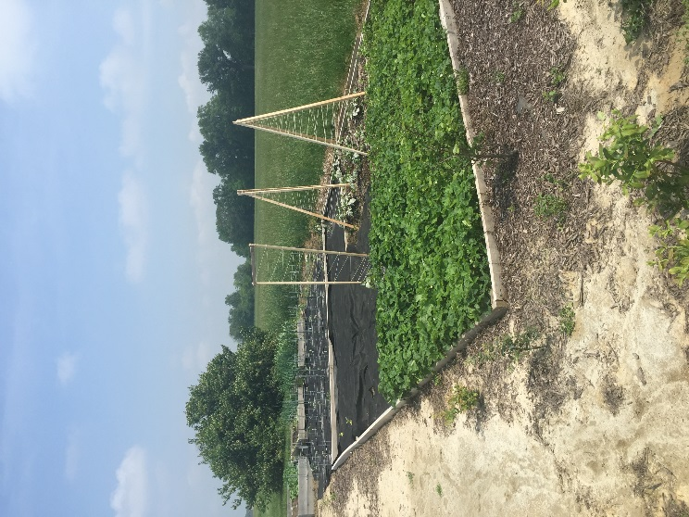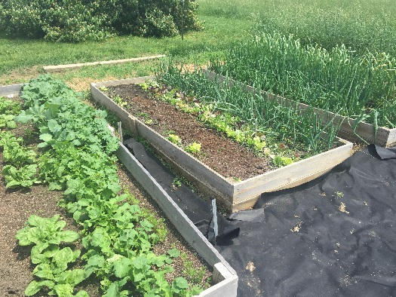

**Photos of a personal garden in Arbor Ridge Estates**

Seasonal farmer’s market within a mile of the neighborhood center? Y_____ N__X___

**Walkability**

Give a tally for the number of services within certain distances of the center of the neighborhood:

SERVICE             <10 min walk (.25 m)            10-20 min (.5m)

grocery

library

community youth center

preschool/daycare

elementary school

middle school

high school

college (any)

senior center

Urgent care or hospital

specialized health practitioner

(dentist, chiropractor, etc)

social services dept.

laundrymat

restaurant

cafe

park

athletic court

gym

(notate if it is included with another service like Elks club, apartment building, etc. What is the membership price?)

(this list can be extended)

What general percentage of streetlights light the main arteries between these services and residences? (circle one)      0%    25%    50%    75%    100%

**There are no services within .5 miles of the neighborhood**

**Presence of litter, curb appeal, and noise**

**(NOTE: We discussed using an app to measure noise decibels but I chose this estimation scale instead, for multiple reasons).**

-Walk 5 minutes (.125 m) down a less-desirable residential street and down a highly-desirable residential street (can be determined largely by real estate prices). Use the Likert Scale to rate the two different locations in the neighborhood on how much litter there is, how aesthetically enjoyable the walk is, and how much noise pollution there is (disturbing or distracting motorized/industrial sounds, animals,people).

Presence of Litter    trash everywhere        moderate            very clean

least desirable        1        2        3        4        5

most desirable        1        2        3        4        5

Curb Appeal        dirty, boring or unsafe        moderate            very pleasing

least desirable        1        2        3        4        5

most desirable        1        2        3        4        5

Noise Level        noises at all times        moderate            pleasant/quiet

least desirable        1        2        3        4        5

most desirable        1        2        3        4        5

**Pedestrian/cyclist/public transportation infrastructure**

Towns with busy streets may require sidewalks, crosswalks, bike lanes and even traffic lights for pedestrian and bike travel, while quiet towns may require slow speeds, buffers, and visibility.  Considering traffic, are there safe pathways to get from residences to services? (circle one)

*Yes, everywhere    most everywhere    only certain routes        no routes*

**Despite the lack of safe routes, country bike rides are very common on the weekends. On average we see 20 bikers on a typical fall weekend on the main road leading to our neighborhood.**

-Are there public transportation options connecting residences to services?

*Yes, everywhere    most everywhere    only certain routes        no routes*

**Access to nature**

Natural areas, for our purposes, can be defined as a public space developed through natural growth rather than design or planning. Examples include a lake shore, natural corridor, and nature trails on the edge of town.

-How many natural areas are within a half mile of the neighborhood center?_**0**___ A mile?_**0**__

**While there are no publicly owned natural areas, each home has a 3 mile lot, many with wooded areas, some with trails.**

**Parks or city maintenance schedules**

Ask your City Public Works or Transportation department what existing schedules/plans they have within your neighborhood for the following :

trash collection (notate how far the drive is if no collection) __**4**_____/month

recycling (and is it free?)  __**0**___/month

park maintenance _____/month or year – **no parks in neighborhood**

street cleaning ___**2**__/ year

street beautification (banners, plantings, art installations) _____/month or year **– none in neighborhood**

parades/block parties/festivals _____/year **– none in neighborhood**