**Public Spaces Tool**

Record the place you visit (name/identification) : **VOLKENING LAKE (ON SCHAUMBURG RD)**

Day and time visited: **30TH OCT 2016 4.00 P.M TO 5.30 P.M AND 3RD NOV 8.00 A.M TO 9.00 A.M**

To assess your public space, use these categories to analyze the different aspects, and respond as indicated.

1. Places to sit
   1. How many chairs/benches/tables? **9 BENCHES , 14 CHAIRS AND 7 PICNIC TABLES**
   2. Are they spread out throughout the space, or clustered together**? EVENLY SPREADOUT**
   3. Height
      1. No higher than average waist? **YES**
   4. Barriers to seating
      1. Any stones or slants? **NO**
      2. Is there a way to adapt to the barrier? **NO**
   5. Width
      1. Is there space for people on either side of the seating areas? **YES**
   6. Are there movable seats?
      1. Do people willingly move the seats? **YES, SOME ARE, WHILE BENCHES ON WALKING TRAIL ALONG THE LAKE EDGES HAVE FIXED BENCHES .**
      2. How many people can sit in the moveable seats? **6**
2. Water
   1. Is it permissible to play in the water? **YES, SAND BEACH IS SPECIALLY CREATED FOR KID’S PLAY**
   2. Is it permissible to wade in? **YES**
   3. Does it provide a soothing “sound effect?” **YES**
3. Public art
   1. Is it interactive? **NOT SO MUCH**
   2. Are you able to sit on it / touch it? **ABLE TO TOUCH IT.**
   3. Is it accessible? **YES**
      1. Is it no more than 3 feet elevated or recessed by stairs from ground level?
4. Open Space
   1. Is there a fair amount of open space? **YES FAIRLY GOOD AMOUNT OF OPEN SPACE**
   2. Is there lots of green space/ hard space? **AVERAGELY GREEN SPACE ON THE WALK WAYS**
      1. Some people may be drawn for certain activities in certain areas
   3. Are there areas for sporting? **YES OPEN GYM ON LAKE FRONT**
   4. Are there areas for picnicking? **YES WITH GAZEBO AND PICNIC TABLES**
   5. Are there areas for small children? **YES**
5. Trees: Rate each on a scale from 1-10.
   1. Are they older? 1=very young “stick’ trees; 5=about two stories tall; 10 very tall, providing shade to street and yards. **SOME ARE ON SCALE OF 5 AND SOME ARE ON SCALE OF 3.**
   2. Are they organized into groves or bunched? 1= just a few places; 10=virtually everywhere. **SCALE OF 1**
   3. Do they provide shade and cover in hot weather? 1=no; 3=for front yards; 5=for walkers; 7=for walkers and parked cars; 10=everything in shade **ONLY SOME AREA OF WALKWAY ALONG LAKE EDGES**
   4. Aesthetically pleasing? **YES**
   5. How much of the space is shaded by trees? 1=part of yard; 5=sidewalk; 10=whole street.
6. Food / Vendors during most usage periods? **YES,THE PARK DISTRICT CONSESSION STAND DURING THEIR OPERATION HOURS i.e uptill 6.00 P.M**
   1. Absent Present for “events” Present seasonally Mostly present
   2. Seating for the vendor? **YES**
   3. Seating (formal and informal) for the public (whether purchasing food or not)? **INFORMAL**
7. Accessibility
   1. Is it easily accessible to the public? **YES**
   2. Can you walk to the public space? Is transportation nearby? Bike accessibility? **YES WE USUALLY WALK TO THIS PUBLIC SPACE AND HAS GOOD BIKE ACCESS.**
   3. Is it a high traffic area? **NO**
   4. Is it easily visible from street? **YES EXTREMELY VISIBLE FROM MAIN STREET OF THE TOWN.**
      1. Does the public space seem open, well lit, and visible enough to feel safe? **YES**
   5. Is the public space occupied by people? **YES,REGULAR WALKERS ARE ALWAYS FOUND TAKING A WALK ON ITS WALKWAY.**
      1. People like to go where other people are
8. Sociability. Rate on a scale from 1-10.
   1. Can you enjoy the space either alone? 10=quickly incorporated into conversations; 1=nobody talked to you except employees. **YES ONE CAN ENJOY THIS SPACE ALONE.**
   2. **Can you enjoy the space in groups? YES ITS INFRASTRUCTURE DOES ENCOUARGE GROUP ACTIVITY LIKE PADDLE BOAT,CANOE, OPEN GYM, GAZEBO AND SAND PLAY AREA.**
   3. Are people socializing? 10= everyone; **5=if they came in groups**; 1=most silent. **(5= THEY COME IN GROUPS**
   4. Do groups of people tend to stay close to each other or are they far apart? **THEY TEND TO STAY CLOSE**
   5. Do people seem to be meeting one another there? 1=no; nobody arrived alone; **10=common YES (10)**
   6. Does it show signs of inaccessibility to different groups? **NO**
      1. Are there signs of racism, sexism, social-class exclusion? **NO**
      2. Are there signs of exclusion by physical abilities? **NO,THE SPACE HAS BEEN DESIGNED TO ACCOMMODATE PEOPLE WITH PHYSICAL ABILITIES.**
9. Time of Day
   1. When are people most likely to be in the public space?
      1. Night (after dark) or daytime? **DAYTIME**
      2. Morning, Afternoon, or Evening? **MORNING & EVENING**
   2. Does the public place “close” **NO,WALKWAY ALONG THE LAKE ARE OPEN 24/7**
10. Vicinity
    1. What is around the space? Classify (circle) and Describe.  
       Houses Apartments Small Businesses School Factory/Big shopping ctr  
       Church Public Bldgs Private land without houses Warehouses  
       **HOUSES ARE FOUND IN THE VICINITY OF THIS WATER FRONT AND RESIDENT OF THIS NEIGHBORHOOD TEND TO ENJOY THEIR WATERFRONT BACKYARD BY BARBEQUE PARTIES,TALKING A WALK AND ENJOYING THE VIEW.**
11. Are there areas to play and exercise?
    1. Large grassy areas**? YES**
    2. Play equipment?
       1. Interactive: basketball courts, tennis courts, chess boards, other **PADDLE BOAT,CANOE.**
       2. Solo: areas to run, fitness “trail,”? **YES (ATTACHED PICTURES)**
12. Cleanliness:
    1. Is the place clean? 1=dirty/unhygienic, 10=surgically clean **SURGICALLY CLEAN**
    2. Is it being actively cleaned (do you see people cleaning it**)? YES, PARK DISTRICT HAS CONTRACTED ITS MAINTENANCE TO LANSCAPE COMPANY WHICH UPKEEP THE SPACE COGENTLY LIKEABLE.**
    3. How accessible are the trash cans? None Few, far apart **MANY,SCATTERED THROUGHOUT.**
    4. How bad a problem is litter? 1=lots of litter, everywhere; **10=no litter**
    5. Are there “Park adopted by…” signs? **NO, AS THIS PUBLIC SPACE IS MANAGED AND MAINTAINED BY SCHAUMBURG PARK DISTRICT.**
       1. Is there evidence that adoption is active? Is trash picked up, etc.? Yes No
13. Decorations within public space?
    1. Banners, flags, flowerbeds, etc**? FLOWERBED, FLAGS AND EVENT BANNERS**
14. Threats and problems diminishing use? (homeless, gang, or threatening people using it? Dangerous or unpleasant spaces, etc.) **SO FAR NONE EXIST AS THIS SPACE IS JUST ADJOINING THE TOWN’S POLICE STATION. FAMILIES,YOUTH, KIDS AND REGULARS (WALKERS,BIKERS AND RUNNERS) KEEP THIS PUBLIC SPACE FILLED WITH ENERGY AND FUN.**

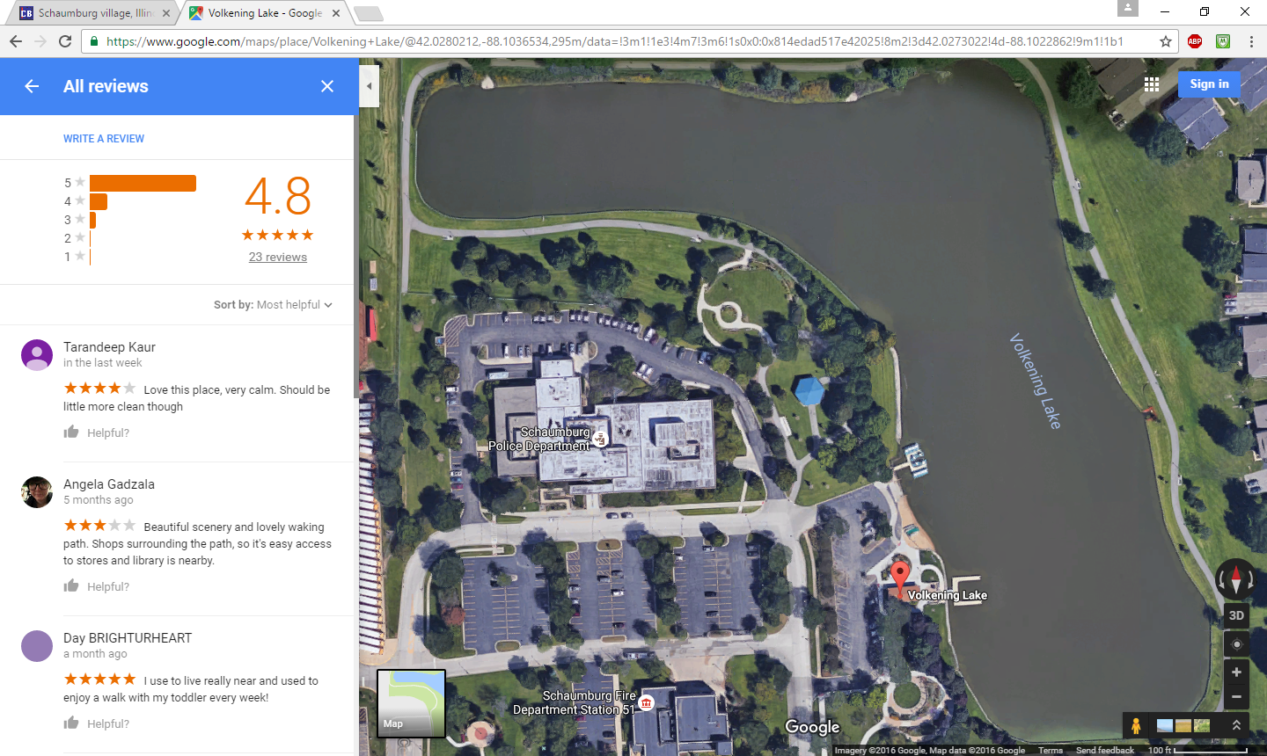

REVIEWS OF THIS PUBLIC WATER FRONT PUBLIC SPACE CAN BE FOUND IN THE ABOVE SNAPSHOT WHICH SHOWS, THE USERS OF THIS SPACE HAVE RATED AT 4.8 ON SCALE OF 5, WHICH ARE CONSIDER A OUTSTANDINGLY POSITIVE REVIEWS.