**Third Place Tool**

For each “third place” in your neighborhood, rate the locale on a 1-5 scale (where 1 is low and 5 is high) for how well each item describes the place.

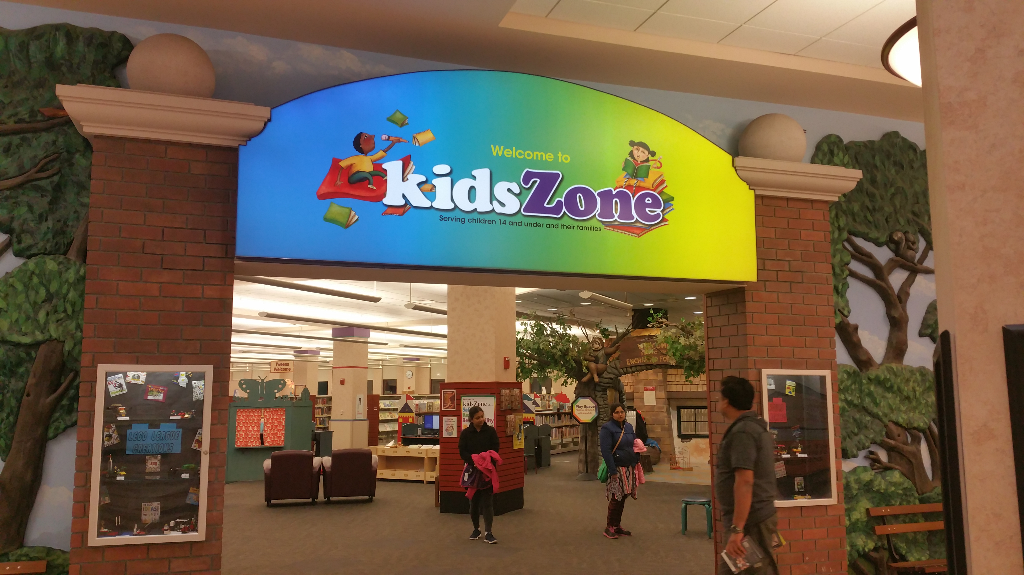

Location or Name of Place: **SCHAUMBURG DISTRICT LIBRARY** Date & Time of visit: **28TH OCT 4TH NOV 2016 (6.30 P.M TO 8.30 P.M)**

Name of neighborhood and sub-section, if any: **TOWN SQUARE**  
Circle one: This place was inside n’hood on n’hood periphery **outside walkable** outside drive

|  |  |
| --- | --- |
| Convenient location/walking distance to center of neighborhood | 4 |
| Leveling: class, income, occupation, age, race and background unimportant | 5 |
| Used by “regulars” from the neighborhood(s) | 5 |
| Conversation as main activity | 4 |
| Conversations “open” to all (not limited to small group) | 4 |
| OK to linger? Is lingering encouraged? Discouraged? | 3 |
| Casual/“Come as you are” | 5 |
| Inexpensive (Approx. price range: **NONE,JUST NEED TO BE VILLAGE RESIDENT)** | 5 |
| Convenient hours. (Hours: 9.00 A.M TO 10.00 P.M DAILY) | 5 |
| Heterogeneous clientele (If homogeneous, describe: age, ethnicity, gender, class, etc.) | 5 |
| People reading paper, doing homework, or engaged in “solo” or isolated activity. | 5 |
| Conversations between workers and customers | 4 |
| Neutral Ground? | 5 |
| Low profile, not fancy or impressive; simple, plain, even rustic. | 5 |
| Playful mood (HAS KIDS PLAY AREA/LIBRARY,HAS MOVIES SECTION | 5 |
| A home away from home | 5 |
| Bulletin Boards & announcements: collect information on ads for local/neighborhood groups or meetings. Who, what and how many? **15** | 5 |
| Programs such as reading groups, activities, etc? Say what age groups they are geared toward. KIDS,TEENS, ACTIVE ADULTS & SENIORS | 5 |

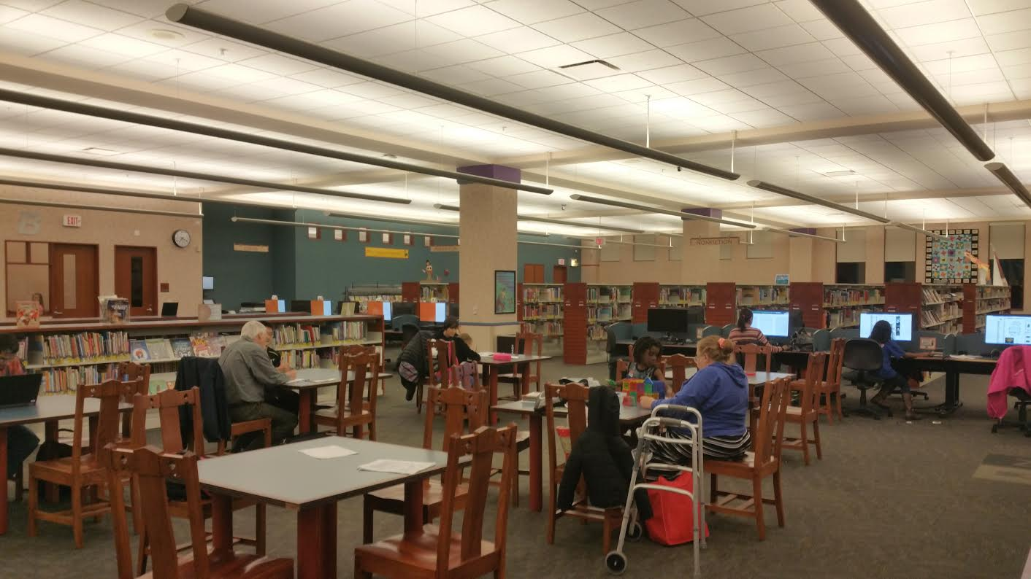

**Rate each area on the following characteristics.**

**Accessibility.**

Parking lot? How many spaces? MORE THEN 100 LOTS

Building capacity (interior, posted): 1,66,500 SQ.FT

Outside capacity, if any,: **NO**

bike racks? **20**

Distance to nearest bus stop? **0.1 MILES**

Sidewalks around establishment?**YES**

Sidewalks leading to establishment from neighborhood?**YES**

Do people appear to arrive in groups or do they come alone?**SOME APPEAR ALONE WHILE** **SOME ARRIVE IN GROUP OR AS FAMILIES.**

Hours:**9.00 A.M TO 10.00 P.M DAILY**

Handicap accessible? **YES , DOORS,ELEVATOR AND FLOOR ACCESS**

Outside lights? **YES ENOUGH STREET LIGHTS.**

**Leveler:**

Diverse clientele? Describe kinds of people **PEOPLE FROM DIVERSE ETHNICITY AND AGE GROUP**

**Age ranges**: _________% children ______ teens _______adults _______seniors

**Income:** ___✓______low income ___✓________ middle income ___✓____upper income

**Race/gender:** mixed or mostly one clientele? **MIXED RACE/GENDER**

**LIBRARY RECEIVES ANNUALY ESTIMATED 493,639 VISITORS.**

**Conversation as Main Activity:**

**Music/TV** volume: **KIDS ARE MOSTLY PLAYING GAMES OR READING BOOKS OR PLAYING COMPUTER GAMES.**

**Patrons:**  Mostly a little talking a lot of loud talking **fun, free ranging discussion**   
(circle one) silent talking **across many tables**

**Playful Mood?** Laughter? Smiling? Joking?

Other descriptives: **KIDS & YOUTH CENTER PROVIDE PLAYFUL ENVIRONMENT GENERATING LOTS OF SMILE & LAUGHTER**

**Regulars**?

Unless you know, ask proprietor, bartender or wait staff about how many regulars they have, where they come from, and who they are (townies; neighborhood residents; workers at particular place; students, etc.

**MOST OF REGULARS AT THE LIBRARY ARE TEENS,KIDS,ADULTS & SENIORS FROM SCHAUMBURG TOWNSHIP AREA AS PATRONS FROM SURROUNDING TOWNS ALSO TAKES BENEFIT OF THE LIBRARY EVENTS AND ACTIVITIES.**

**\*\*\*\*\*\*\*\*\*\*\*\*\*\*\*\*\*\*\*\*\*\*\*\*\*\*\***