NRES 598: Human Dimensions of the Neighborhood Environ, Fall 2016  
(Draft of) **Neighborhood Civic Life Tool**.  
Review for class on Wednesday, 10/12/2016.

## House price, crime, and demographic data

### Type in the address of a house in the neighborhood.

1. **Meadow St.**

### Record the estimated value (or price, if for sale).

**$239,900**

### Average list price for similar homes for sale in this neighborhood and in this zip code.

**$120,000**

### Record the number of major crimes (violent, non-violent crimes) near the home in 2016.

**\*no crimes listed\***

### Population stats:

### **median age (42) , percent married (73%), percent college graduates (25%)**

### Record the schools (and their quality) and distance to schools.

**Grant Park School District K-12 Rated 8 out of 10 and .4 miles from home.**

### Use walkscore.com

**Walkscore = 38 Transitscore = no public transportation**

### Population Density.

**Population Density: 2,101 people per square mile (low) (taken from** <http://www.city-data.com/city/Grant-Park-Illinois.html>)

## Average length of residence (turnover rate). How often do people leave the neighborhood?

### Add up the sales over the year **(12)**, then divide by the number of homes. **(204)**

#### The annual houses sold/total homes ratio is the turnover rate. **(12/204=.059)**

#### Average length of residence can be estimated by 1/turnover (where annual turnover rate is given as a probability) or 100/turnover (when turnover is expressed as a percentage). **16.59**

# **Political Activity Measures**

### **As the neighborhood encompasses the whole town, 100% of our board members live in the neighborhood.**

## Find out if your neighborhood has an Elks, Moose, or Eagle Lodge within or near it. **We have an American Legion and Lions Club in town.**

## Find out if your neighborhood as a Home Owners Association or a Neighborhood Association.

### **No type of associations**

## Record number of homes with yard signs for candidates and political or social causes (examples include “My house pays Carle’s Property Tax” signs, “We Support the Community Broadband” signs, etc.,). Record the number of homes with “little libraries” and “little pantries” in their front yards. **37/204 have civic signage**

### Report the numbers of homes for each of the above; convert this to a percentage of homes and report percentage as well. **.1666**

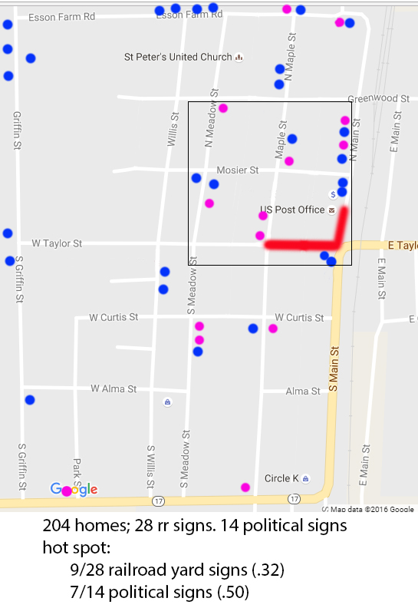

# **Non-Political Engagement**.

## Drive or walk through the streets of your neighborhood. (You are doing this already for part II; don’t make more work than needed: obviously you can record this on the walkthrough noted above!)

### Using a checklist, record the numbers of the following within the neighborhood and within a ten minute walk of the neighborhood. Keep lists separate (for within neighborhood and within a ten minute walk.

__3_____ Schools

___4____ Restaurants (including coffee shops)

____4___ Parks

_____1__ Libraries

_1______ Open Markets (Farmer’s Markets, etc.)

__1_____ Retail Stores

___1____ Community service organizations (ex: neighborhood watch, gardeners’ club, etc.)

__1_____ Community sports organizations (community softball league, etc.)

___2____ Availability of local newspaper subscriptions

____4___ Churches / religious centers

_1______ Community centers

__0_____ Theatres

___0____ Walking trails

## Drive or walk through the streets of your neighborhood. For this, evening (dusk) or slightly after dark is best. May be combined with the above, but actually this is usually easier if done on a separate walkthrough or drive-through.

### Record the numbers of homes with outside holiday decorations and no decorations on each street.

### Report by street, and for neighborhood as a whole.

#### It is not uncommon to find streets with no decorations and streets with many decorations in the same neighborhood.

**Total: 96/204**

**Main Street: 12**

**Maple Street: 21**

**Meadow Street: 21**

**Willis Street: 1**

**Park Street: 13**

**Griffin Street: 18**

**Esson Farm Road: 4**

**Greenwood Street: 1**

**Mosier Street: 1**

**Alma Street: 1**

**Route 17: 3**

