**Norfolk, VA Tammy Knecht Health assessment tool**: How conducive is your neighborhood to good health?

**Proximity to pollution sources (industry, road congestion)**

-count cpm’s (cars per minute!) on the busiest street and slowest street. Do this at 5:30 pm (up for debate). Count cars going by for 1 minute, then wait a minute and do it again. Do this three times and then take the average.

Busy Street:

20 cpm’s

11 cpm’s

23 cpm’s

*18 average*

Slow Street:

4 cpm’s

0 cpm’s

0 cpm’s

1.3 average

-Are there any major sources of pollution in the neighborhood or within a quarter mile? This can just be tallied up as a “score”. Ex.: within neighborhood:2 , near neighborhood: 1. For the sake of simplicity, let’s assume this is anything with a smokestack, discharge pipe, brownfield, superfund site, or commonly known source of contaminants. Probably big industry. Disregard potential of lead or asbestos in buildings unless it is commonly known.

within neighborhood: 0 What?_______________________________

within a quarter mile of neighborhood: 0What?

Score (sum as noted above): 0

**Access to fresh, nutritious food**

-This is an easy “score”, and can be done with google maps: How many year-round places to buy fresh produce and groceries from the center of your neighborhood (find the center of the widest distance in your ‘hood)?

within a 10 minute walk (.25 mile): year-round noneseasonal none

between a 10 and 20 minute walk (.5 mile): year-round noneseasonal none

-Is there a food bank, soup kitchen or community food aid within a mile of the neighborhood center? Y__ N

-Is there a community garden within a mile of the neighborhood center? Y___ N

Seasonal farmer’s market within a mile of the neighborhood center? Y_____ N

**Walkability**

Give a tally for the number of services within certain distances of the center of the neighborhood:

|  |  |  |
| --- | --- | --- |
| SERVICE | <10 min walk (.25 m) | 10-20 min (.5m) |
| grocery | 0 (convenient store 2) | 0 |
| library | 0 | 0 |
| community youth center | 0 | 0 |
| preschool/daycare | 1 | 0 |
| elementary school | 0 | 0 |
| middle school | 0 | 0 |
| high school | 0 | 0 |
| college (any) | 0 | 0 |
| senior center | 0 | 0 |
| Urgent care or hospital | 0 | 0 |
| specialized health practitioner (dentist, chiropractor) | 1 | 0 |
| social service dept. | 0 | 0 |
| laundrymat | 0 | 0 |
| restaurant | 0 | 0 |
| cafe | 0 | 0 |
| park | 1 | 0 |
| athletic court | 0 | 0 |
| gym | 0 | 0 |

What general percentage of streetlights light the main arteries between these services and residences? (circle one)      0%    *25%*    50%    75%    100%

**Presence of litter, curb appeal, and noise**

**(NOTE: We discussed using an app to measure noise decibels but I chose this estimation scale instead, for multiple reasons).**

-Walk 5 minutes (.125 m) down a less-desirable residential street and down a highly-desirable residential street (can be determined largely by real estate prices). Use the Likert Scale to rate the two different locations in the neighborhood on how much litter there is, how aesthetically enjoyable the walk is, and how much noise pollution there is (disturbing or distracting motorized/industrial sounds, animals,people).

Presence of Litter    trash everywhere        moderate            very clean

least desirable        1        2        3        4        5

most desirable        1        2        3        4        5

Curb Appeal        dirty, boring or unsafe        moderate            very pleasing

least desirable        1        2        3        4        5

most desirable        1        2        3        4        5

Noise Level        noises at all times        moderate            pleasant/quiet

least desirable        1        2        3        4        5

most desirable        1        2        3        4        5

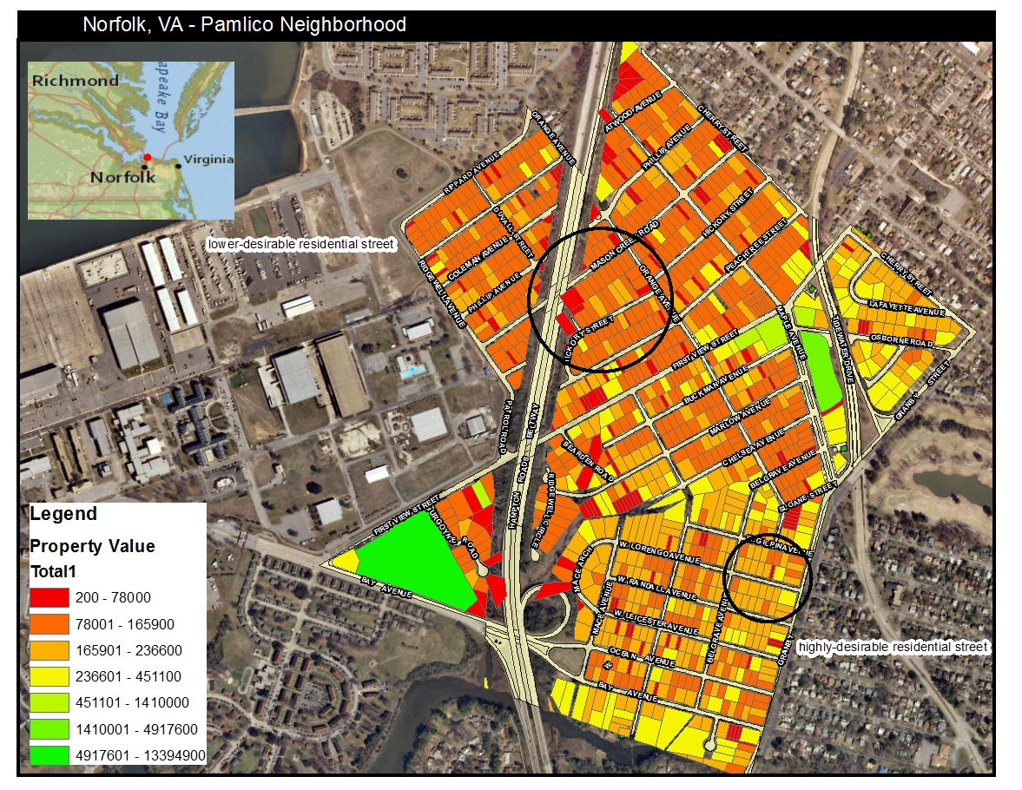

**Pedestrian/cyclist/public transportation infrastructure**

Towns with busy streets may require sidewalks, crosswalks, bike lanes and even traffic lights for pedestrian and bike travel, while quiet towns may require slow speeds, buffers, and visibility.  Considering traffic, are there safe pathways to get from residences to services? (circle one)

*Yes, everywhere    most everywhere    only certain routes        no routes*

-Are there public transportation options connecting residences to services?

*Yes, everywhere    most everywhere    only certain routes        no routes*

**Access to nature**

Natural areas, for our purposes, can be defined as a public space developed through natural growth rather than design or planning. Examples include a lake shore, natural corridor, and nature trails on the edge of town.

-How many natural areas are within a half mile of the neighborhood center? *1* A mile? 0

**Parks or city maintenance schedules**

Ask your City Public Works or Transportation department what existing schedules/plans they have within your neighborhood for the following:

trash collection (notate how far the drive is if no collection) 4/month

recycling (and is it free?)  2x /month Free

park maintenance 1x /month

street cleaning 1x /month

street beautification (banners, plantings, art installations) 0x / year

parades/block parties/festivals 0/year